R | O |  | Y |  |  | A |  | L
 |  | Lifelong Readers and Learners |  |  |  |  | Empowered Educators
Culture of Readers
 |  |  |  | 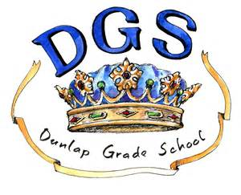
 |  | Independent Readers |  |  |  |  | Reading Emergency
 |  |  |  | Balanced Reading Diet

