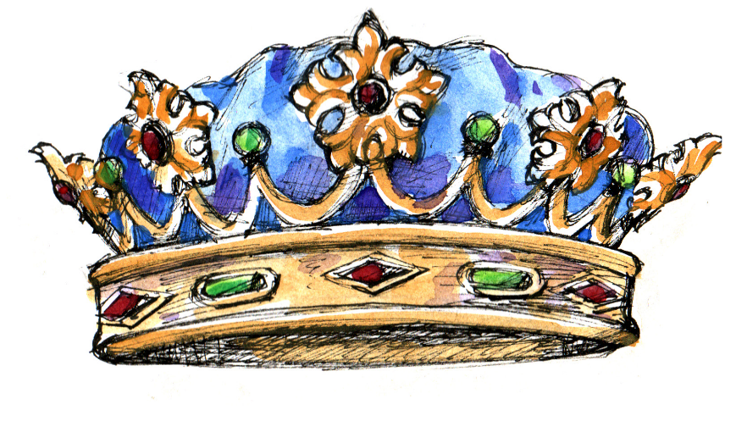
I am Worthy
#dgsroyals
I am smart
#dgsroyals
I am capable
#dgsroyals
I am valued
#dgsroyals
I am creative
#dgsroyals
I am kind
#dgsroyals
I am enough
#dgsroyals
I belong
#dgsroyals
I can
achieve
#dgsroyals
I can
do hard things
#dgsroyals
I am brave
#dgsroyals
I am strong
#dgsroyals
I am talented
#dgsroyals
I am unique
#dgsroyals
I am amazing
#dgsroyals

